Philosophy of Zygoma Esthetic Rehabilitation by Different Surgical Approaches for Treatment of Zygomatic Bone Fracture

Najat R. Ali (BDS; FICMS)  Department of Surgery, Faculty of Dentistry, University of Kirkuk, Kirkuk, Iraq | Received: 13-January-2023  Revised: 24-February-2023  Accepted:21-March-2023
Abstract
Introduction: Zygomatic bone is the prominent bone in facial skeleton and commonly exposed to trauma whose important sustain to restore the malar eminence due to its impact on esthetic shape of the face and cheek.
Objective: Different surgical approaches had been used for reduction and fixation of zygomatic bone fractures and follow-up for 2 years in order to determine postoperative complications with each approach.
Results and discussion: A few new methods to conducting surgical interference to perform a stable type of fracture without diplopia, enophthalmus with no limitation in eye motion was treated conservatively, while the unstable type should be treated surgically. It is concluded that various surgical approaches could be used to treat zygomatic bone fractures pending on type of bone trauma.

Key wards: Rehabilitation; bone fracture; surgical approaches; Treatment; Zygomatic complex fractures

Introduction
Zygomatic (or cheek bone), a malar bone that give esthetic shape to the face consists of four process that articulate with other facial bones which articulates with zygomatic process of frontal bone at the fronto-zygomatic suture area. It also articulate with zygomatic process of maxilla at the zygomatico maxillary suture area while its articulation with zygomatic process of temporal bone together with it form the zygomatic arch. Zygomatic bone forms a large portion of the orbit and together with the sphenoid bone, forms part of the orbital floor , because of the three process of zygomatic bone are involved in the fracture which are often described as tripoid fractures. Some clinician describe it as quadripoid fractures, as the fourth process, where the orbital process is also involved.⁽¹⁾ The etiology for fractured zygoma could be due to road traffic accidents, violent assaults, falls, war injuries and sports.⁽²⁾ Clinical presentation of zygomatic bone fractures are either diplopia, enophthalamus, subconjectival hemorrhage, circumorbital ecchymosis, extraoccular mascule entrapment, cosmetic deformity, malocclusion, facial widening, depression of malar eminence, neurosensory disturbance of the infraorbital nerve or/and limitation of mouth opening.⁽³⁾ Eight types of zygomatic complex fracture have been classified in 1968 by Rowe and Killey (1968)⁽⁴⁾: Type I: No significant displacement; Type II: Fractures of the zygomatic arch; Type III: Rotation around the vertical axis i.e. (a). Inward displacement; and (b). Outward displacement; Type IV: Rotation around the longitudinal axis i.e. (a). Medial displacement of frontal process and (b). Lateral displacement of frontal process;
Type V: Displacement of the complex en bloc e.g. Medial, Inferior or Lateral (rare); Type VI: Displacement of the orbito-antral partition, e.g. Inferior or Superior (rare); Type VII: Displacement of orbital rim segments; and Type VIII: Complex comminuted fractures.
In 1985 Rowe changed his 1968 classification and gave more clinical significance by dividing fractures into stable and unstable varieties⁽⁴⁾ i.e. Group A: Stable fracture, shows minimal or no displacement that require no intervention; Group B: Unstable fracture, with great displacement and disruption at the fronto-zygomatic suture and comminuted fractures that require reduction as well as fixation; Group C: Stable fracture and other types of zygomatic fractures, which require reduction, but no fixation. Those fracture of the zygomatic arch alone not involving the orbit can be classified as either (a). Minimum or no displacement; (b). V-type infracture or (c). Comminuted fracture.
Zygomatic bone fractures can be reduced either by close or by open reduction. The close reduction of the fracture is based on self-retaining nature of the fracture, since zygomatic fractures are self-retaining, due to its sutural joints with the adjacent bones which should be done and be treated within 72 hours, otherwise, a chance of the restorative and remodeling activity at the sutural border and rounding sutures would be increased, which reduces self-retaining of the fracture.⁽¹⁾ Different surgical methods and approaches for close reduction can be used to obtain successful treatment outcome of fractured zygoma, including the Gillies temporal approach, keens intraoral approach, trans-antral approach.⁽⁵⁾ However, for reduction and fixation of unstable zygomatic complex fractures other approaches can be used i.e. coronal, eyebrow, upper eyelid, trans-conjectival, subcilliary and infra-orbital approaches.⁽⁶⁾ Open reduction and fixation of fracture zygoma is indicated in: Severly displaced and impacted fractures which do not yield to the closed reduction; Old fractures, which are not self-retaining; Malunited fractures; Comminuted fractures; and in Fractures where functional loss is like diplopia, enophthalmos, proptosis, restriction of the mandibular excursion^{.(1)}

Materials and methods:
This is a prospective study for 32 patients (26 male and 6 female) with zygomatic bone fractures were selected from department of maxillofacial surgery in Azadi Teaching Hospital, Kirkuk, Iraq, for the period of January 2018 - December 2020. The age of the patients ranged between 9-60 years with an average (28.68 years). The zygomatic complex fractures were confirmed by CT-scan. Sign and symptoms of zygomatic fractures were evaluated as diplopia, enophthalamus, restricted mouth opening, occlusal alteration, neurological disturbance of infra-orbital nerve and impaired vision.
Protocol: Clinical and radiological confirmation by using CT-scan had been done for fracture displacement. Conservative treatment without intervention conducted in 3 patients; close reduction without fixation conducted in 11 patients; while open reduction with fixation had been conducted in 18 patients. Time interval between injury and surgical intervention ranged from 0-14 days. Gilles approach and keen intraoral vestibular approach had been used for close reduction of fracture zygoma while stainless steel wire fixation had been conducted in 5 patient for open reduction. Plate fixation with adequate mini-plate osteo-synthesis was performed in 13 patients. Only a single point fixation in 9 patients; two point fixations in 5 patients and 3 point fixation had been done in 4 patients. Patients hospitalization after surgery range from (1-7) days. All surgical and nonsurgical treated patients were advised not apply pressure on the fractured side for a period of six weeks and were followed on a weekly basis for the first four weeks postoperatively, then at three months and one year.

Results:
The causes of injury were various i.e. road traffic accidents (62.5%), sport injuries (12.5%), war (blast) injuries (9.375%), violent assaults 3 cases (9.375%), gunshot one case (3.125%) and fall one case (3.125%) (Table 1). Ten of these patients had concomitant facial fractures involving nose (3), mandible (5) and lefort I/II/III fractures (2). Treatment.

(Table-1): Etiology of zygomatic bone fractures
Etiology of fractures | No. of cases | Percentage (%)
Road traffic accidents (RTA) | 20 | 62.5
Sport injuries | 4 | 12.5
War injuries (Blast injuries ) | 3 | 9.375
Violent assaults | 3 | 9.375
Gunshot | 1 | 3.125
Falls | 1 | 3.125
Total | 32 | 100

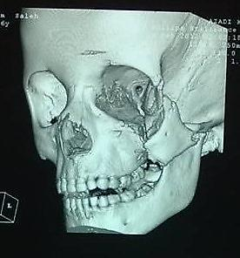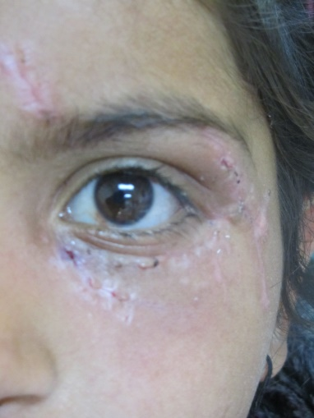
C
B
A
(Fig.1): Zygomatic complex fracture: (A). A CT-scan shows downward displaced fracture zygoma; (B). Fixation of fracture by micro plate through the wounds and (C). Postoperative photograph.

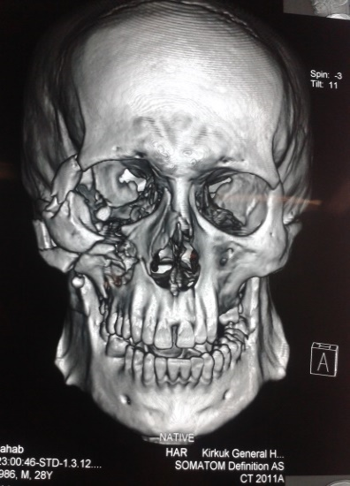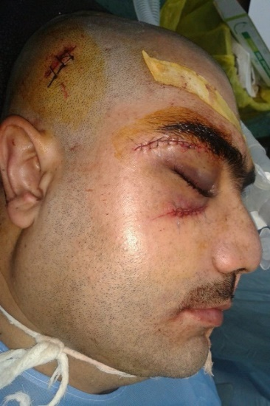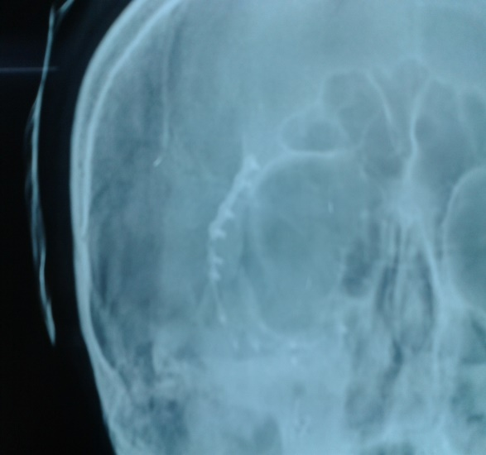
C
B
A
(Fig.2): Comminuted zygomatic bone fracture: (A). A CT-scan shows comminuted zygomatic complex fracture; (B). Intra-operative view shows Gillis incision, lateral eyebrow incision and infra-orbital incision and (C). A post-operative radiograph shows fixation points.

The age range of the most cases (10 patients) was between (21-30 years (31.25%); 6 patients (18.75%) were in 11-21 years and 5 patients (15.625%) were in 1-10 years respectively; while the other cases were divided in between them. Only 6 cases were female while 26 of the cases were male. The etiology of the zygomatic bone fracture was mostly by road traffic accident (62.5%); sport injury (12.5%); war injury (9.375%); violent assaults (9.375%); gunshot (3.125%) and fall from height made a single (3.125%) [Table-1].

Treatment protocol:
Despite a variety of schemes usable to classify zygomatic fractures, the Rowe classification system 1985 was used as shown in table 2. Only 3 cases (9.375%) from group A were treated conservatively without surgical intervention due to stable fracture without displacement upon CT scan. However, 18 cases (56.25%) from group B were treated by open reduction and fixation by stainless steel wire or by titanium fixation plate as they had unstable fractures with a reasonable displacement and disruption at fronto-zygomatic suture, zygomatico-maxillary suture, impure lower orbital rim fractures and comminuted fractures. Other 11 cases (34.375%) from group C treated by close reduction without fixation because they had stable zygomatic arch fractures alone without involving the orbit (Table-2).

(Table.2): Treatment protocol according to Rowe (1985) classification for fracture zygoma.
Type of fracture zygoma |  | Type of treatment | No. of cases | Percentage
Group A | Stable fracture: showing minimal or no displacement | Conservative | 3 | 9.375
Group B | Unstable fracture: with great displacement and disruption at the frontozygomatic suture and comminuted fractures. | Open reduction and fixation | 18 | 56.25
Group C | Stable fracture: other types of zygomatic fractures,which required reduction, but no fixation. fracture of the zygomatic arch alone not involving the orbit can be classified as follows:  - Minimum or no displacement  - V type infracture  - Comminuted fracture. | Close reduction | 11 | 34.375
Total |  |  | 32 | 100%

Approaches used for open and close reduction and fixation of zygomatic fractures and associated postoperative complications:
The following approaches were used in this study: (1). Gillis approach had been used in 17 cases for reduction of displaced zygomatic fracture by using Bristo elevator without postoperative complication; (2). Keen intraoral approach used in 7 patients for reduction of zygomatic fracture by using Row elevator without postoperative complication; (3). Lateral eyebrow incision was used in 10 cases for fixation of fronto-zygomatic suture area without postoperative complication; (4). The infra-orbital approach was used in 6 cases for fixation of displaced lower orbital rim fractures approach on case temporary lymphedema another case of cheek numbness occur; (5). subcilliary incision used in 3 cases for fixation of lower orbital rim fracture which shows temporary ectropion in 2 cases; and (6). through the wound used in 3 cases which shows skin scar as postoperative complication (Table.3).

(Table-3): A few Approaches being used for open and close reduction of zygomatic bone fracture and their postoperative complications:
 | Approaches | No. cases | Postoperative Complication
1. | Gillis approach | 17 | Skin scar
2. | Keen Intraoral approach | 7 | No
3. | Lateral eyebrow | 10 | Skin scar
4. | Infra-orbital approaches | 6 | one case infra-orbital lymphedema and numbness of cheek in one case
5. | Subcilliary | 3 | 2 case of temporary ectropion
6. | Through the wound | 3 | Skin scar

Discussion
Re-establishment of facial malar contour, position of the eye globe, restore dental occlusion as well as mandibular movement is essential in the treatment of zygomatic bone fracture. The stable zygomatic complex fractures in patients with or without minimal displacement nor diplopia, enophthalmos, limited eye globe motion due to extra-ocular muscle entrapment, limited mouth opening and mandibular movement and depression of malar eminence, were treated conservatively without surgical intervention which are in consistent with other researches and this is agree with. ^{(2,3,5)} The unstable zygomatic complex fracture with great displacement and disruption at fronto-zygomatic, zygomatico-maxillary and comminuted fractures treated by open reduction and fixation via stainless steel wire or fixation plate in order to restore malar contour, restore dental occlusion and freeing eye globe and mandibular movement acoording to other researches.^{(7,8)} while the displaced stable fracture of zygomatic arch alone without orbital involvement treated with closed reduction without fixation. ⁽¹⁾ Fixation of zygomatic complex fracture could be done in either one, two or three points however there is no consensus agreement regarding the number of fixation points, sequence of rigid fixation or surgical approach exist. ⁽⁸⁾
Different surgical approaches can be used for reduction and fixation of unstable zygomatic complex fractures, in this study Gillis, Keen intra-oral approach, lateral eyebrow incision, infra-orbital and subcilliary approaches had been used for reduction and fixation of unstable fractures.
Gillis approach is acceptable for reduction the arch of zygoma but it need more dissection for soft tissue and its associated with skin scar which is covered by hair, Keen intra-oral approach considered the most acceptable approach according to this study for reduction of zygomatic arch fracture because of easy access for zygomatico-maxillary area for reduction and fixation of zygomatico-maxillary complex fractures and exploration of infraorbital nerve. Infraorbital approaches used for exploration and fixation of lower orbital rim fracture, the incision done with skin creases but may be associated with temporary postoperative lymphedema and numbness of cheek due to disruption to distribution of branches of infraorbital nerve, while Subcilliary incision its an invisible incision used for exploration and fixation of lower orbital rim fracture but may be followed by temporary postoperative ectropion ⁽⁹⁾, when zygomatic complex fracture is a compound fracture access to operative field done through the wound and this is end by skin scar.

Conclusion:
Various approaches used for reduction and fixation of zygomatic bone fractures, follow-up for 2 years had revealed that Keen's intra-oral approach was easiest and fastest to reach the malar bone without postoperative complications, while Gillis approach for lateral eyebrow and through the wound showed skin scars postoperatively. The infra-orbital approach showed temporary lymphedema and cheek numbness meanwhile the sub-cilliary incision showed temporary ectropion postoperatively. Fixation of zygomatic complex fracture could be performed in either one, two or three points, yet, there is no consensus agreement regarding the number of fixation points, sequence of rigid fixation or surgical approach exist.

Acknowledgement: This research is conducted upon Ethical Code of Conduct where no personal details are disclosed while pictures are displayed upon the approval of the patients themselves. Thanks are due to professor Dr. Ayoub A. Bazzaz, the Dean of Faculty of Medical Technology, University of Al-Kitab, Altun Kopri, Kerkuk, Iraq for proofread and revising the English language of this manuscript.

Reference:
- Borle, MR (2014). "Textbook of Oral & Maxillofacial Surgery". 1st ed. New Delhi: Borli Rajiv M; Arora Aakash, Singh Divya; Chapter 21: Fractures of Middle Third of Facial Sleleton; p:449-450.
- Farber, SJ; Nguyen, DC; Skolnick, GB; Woo, AS; and Patel, KB (2016). Current management of zygomati comaxillary complex fractures: A multidisplinary survey and literature review. Craniomaxillofactory Trauma reconstruction; 9(4): 313-322.
- Ellstrom, CL and Evans, GR (2013). Evedence-based Medicine: Zygoma fracturtes. Plast. Reconstr. Surg; 132(6): 1649-1657.
- Malik, MA (2010). "Textbook of Oral and Maxillofacial Surgery" 2nd ed. New Delhi: Neelima Anil Malik; Chapter 29: Fracture of the middle third of the facial skeleton; p 359.
- Ellis, E and Kittidumkerng, W (1996). Analysis of treatment for isolated zygomaticomaxillary complex fractures. J. oral maxillofac. Surg. 54(4): 386-400.
- Birgfeld, CB; Mundinger, GS and Gruss, JS (2017). Evidence-based Medicine: Evaluation and treatment of zygoma fractures. Plast. Reconstr. Surg; 139(1): 168e-180e.
- Courtney, DJ (1999). Upper buccal sulcus approach to management of fractures of the zygomatic complex: A retrospective study of 50 cases. Br. J. Oral Maxillofac. Surg. 37(6): 464-466.
- Starch-Jensen, T; Linnebjerg , LB and Jensen, JD (2018). Treatment of Zygomatic Complex Fractures with Surgical or Nonsurgical Intervention: A Retrospective Study. Open Dent J; 12: 377-387.
- Baek, JE; Chung, CM and Hong, IP (2012). Reduction of Zygomatic Fractures Using the Carroll-Girard T-bar Screw. Archives of Plastic Surgery; 39: 556-560.

